**CS 457/557 -- Winter Quarter 2021**

**Project #4**

**Cube Mapping Reflective and Refractive Bump-mapped Surfaces**

**Name: Chun-Yu Chen**

**E-mail:** [**chench6@oregonstate.edu**](mailto:chench6@oregonstate.edu)

* What I did and explaining why it worked this way

1. I applied the concept of the project#3 to create the square first
2. Add the reflect and refract functions after I done the first step then I can get the result of the new value of reflect and refract
3. In the end, mix refractColor and reflectColor to determine how many portion of them will be shown.

* 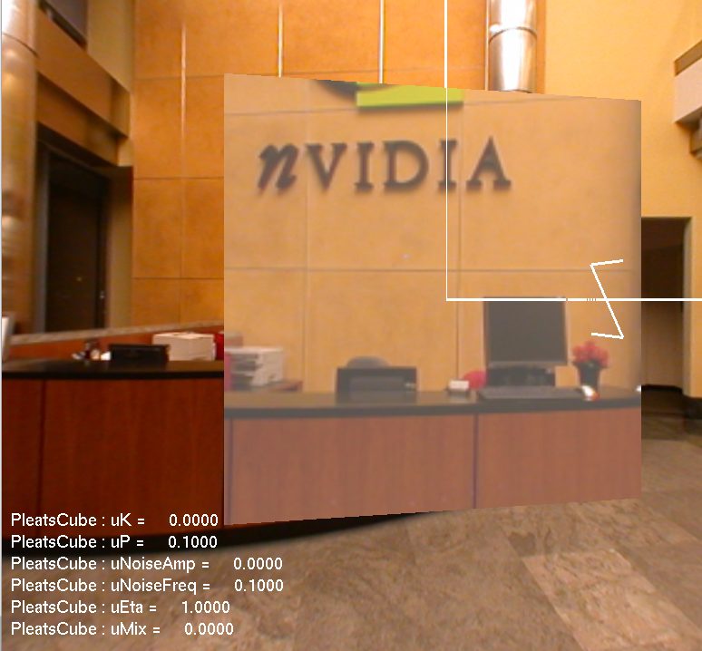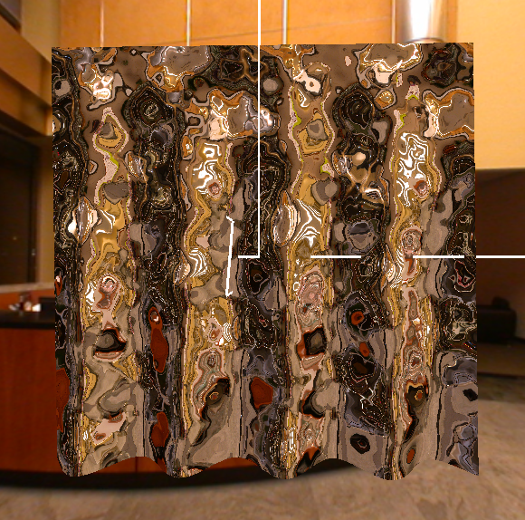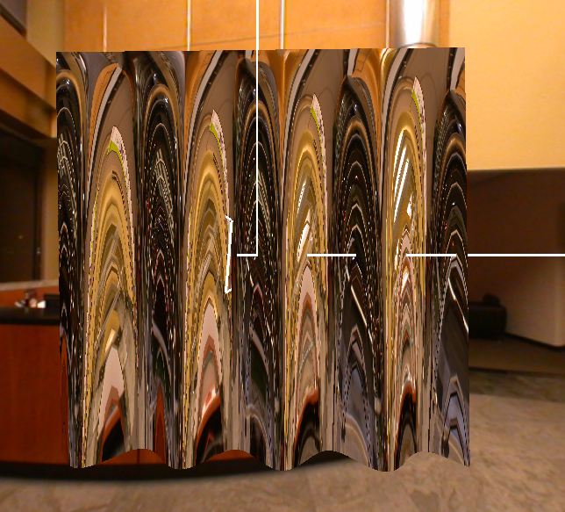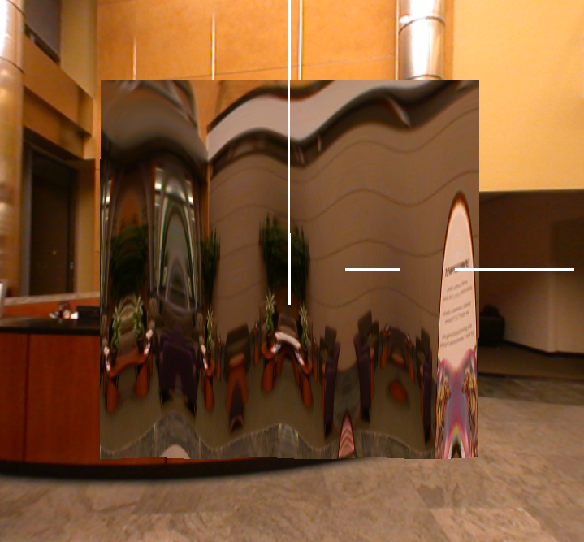Screen shots from program:

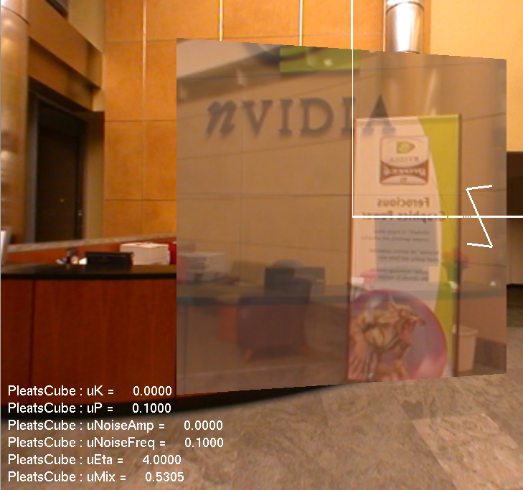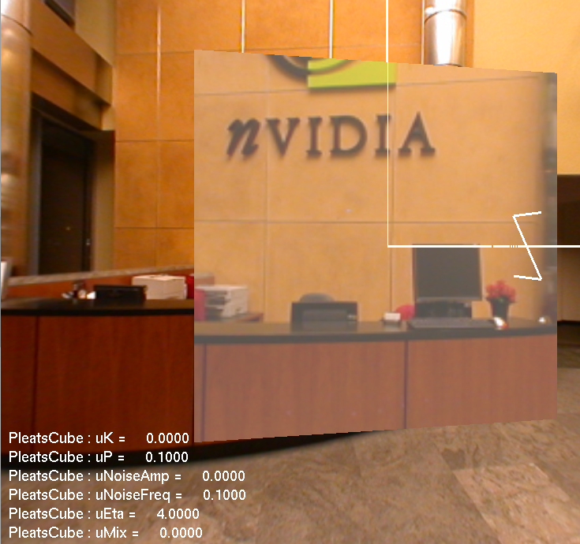

* Video Link: <https://youtu.be/9tgf3yYujx8>